PHP framework project

Food booking system

Ho minh thang – DIN15SP

foodie – the food shop

link:

# Idea of the food booking system

The food booking system is used to book the food from the store for convenience, customers are able to purchase the food online then they will receive the food after a specific time gaining by our system.

The customers are able to create the reservation on the website, by choosing (add food) from the list from our website. They are able to modify it before purchasing this.

# Database system

Table of food will contain:

* ID of products / food
* Name of the food
* Price
* Description
* Images

Table of Customers will contain:

* ID of customers
* Name
* Address
* Phone number

Table of order detail will contain

* ID of food (just in order)
* Productid (id of the food – link to table of the good)
* Quantity of food
* Price

Table of feedback will contain

* Id of comment
* Customer email
* Comments

# Database create code

**Table customers:**

CREATE TABLE `customers` (  
 `id` int(11) NOT NULL AUTO_INCREMENT,  
 `name` varchar(80) NOT NULL,  
 `address` varchar(80) NOT NULL,  
 `phonenumber` varchar(20) NOT NULL,  
 PRIMARY KEY (`id`)  
) ENGINE=InnoDB AUTO_INCREMENT=18 DEFAULT CHARSET=utf8

**Table foods:**

CREATE TABLE `food` (  
 `id` int(100) NOT NULL,  
 `name` text NOT NULL,  
 `price` float NOT NULL,  
 `description` varchar(255) NOT NULL,  
 `image` varchar(80) NOT NULL  
) ENGINE=InnoDB DEFAULT CHARSET=utf8

**Table order_detail:**

CREATE TABLE `order_detail` (  
 `id` int(11) NOT NULL AUTO_INCREMENT,  
 `productid` int(11) NOT NULL,  
 `quantity` int(11) NOT NULL,  
 `price` float NOT NULL,  
 PRIMARY KEY (`id`)  
) ENGINE=InnoDB AUTO_INCREMENT=18 DEFAULT CHARSET=utf8

**Table feedback:**

CREATE TABLE `feedback` (  
 `id` int(11) NOT NULL AUTO_INCREMENT,  
 `customer_email` varchar(50) NOT NULL,  
 `comments` varchar(255) NOT NULL,  
 PRIMARY KEY (`id`)  
) ENGINE=InnoDB AUTO_INCREMENT=3 DEFAULT CHARSET=utf8

# how to use the documents

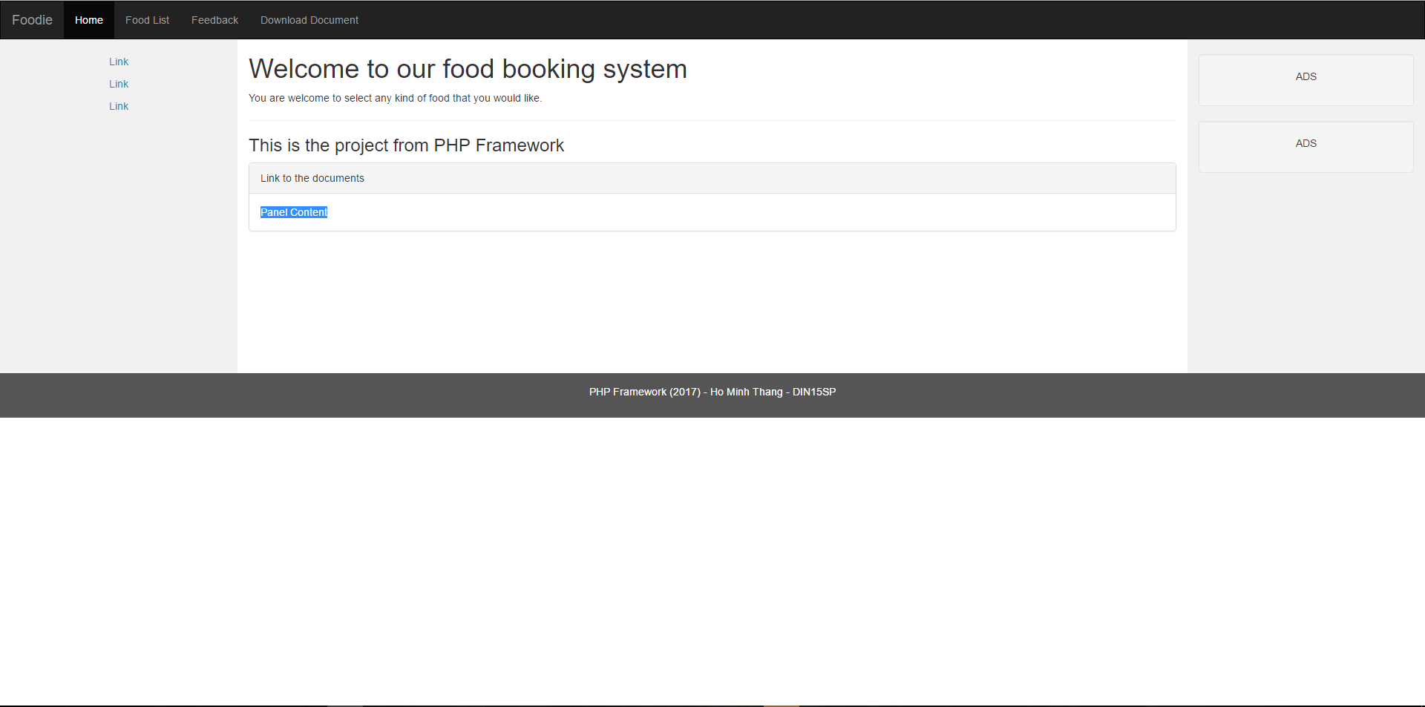

This is how the main page will display, the bar in top is the menu, the name of the project is “Foodie”.

The home button has a darker color than the other, which indicated that you are in Home.

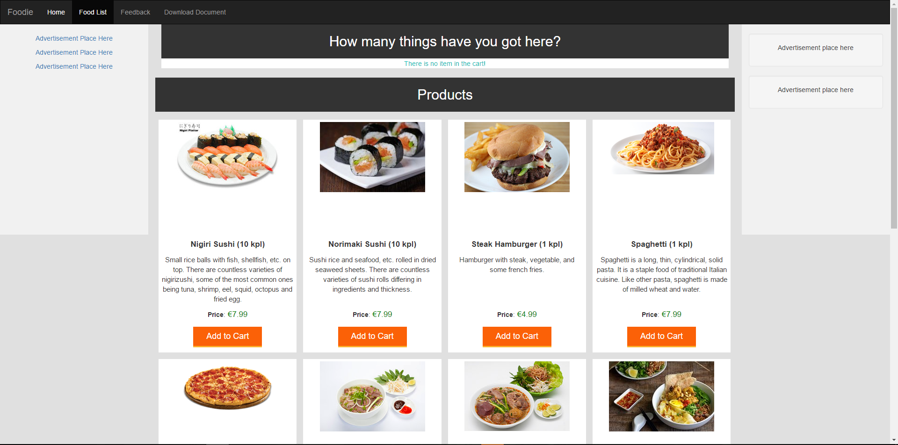

Then, this is the product page, which contains all the products loading from the database.

“How many things have you got here? “ and “There is no item in the cart” means that you’ve never chosen any kind of foods here.

When you press “Add to Cart”, which will add items to the cart, the cart is an element which has been existed in CodeIgniter, the cart just temporarily holds what you have been adding to it, and it is not properly in database.

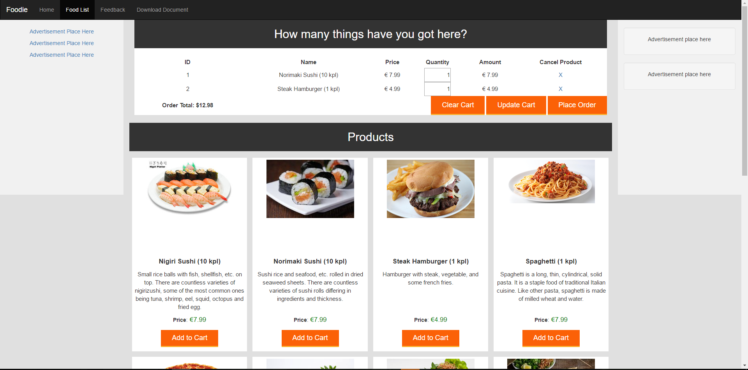

For example, when you click on “Add to cart” for example: Norimaki Sushi and Steak Hamburger, the line “There is no item in cart” will disappear, instead of that two new products that you pressed “Add to cart” has been added to the view above.

You can cancel the product by clicking the X on cancel product.

You can update cart by changing the quantity of the products, then click on “Update Cart”, the Order Total price will change.

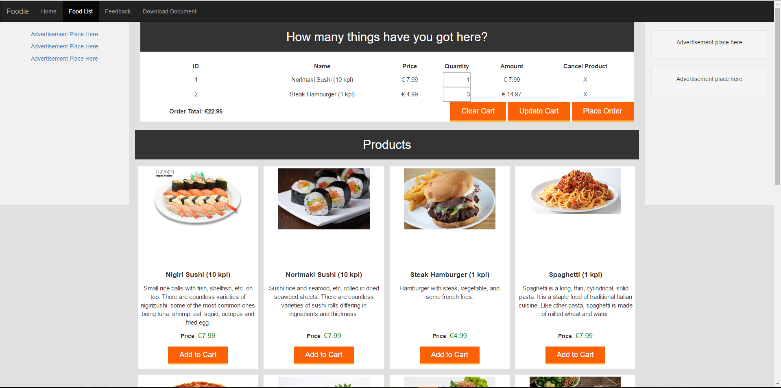

For example, I have changed the quantity to 3, and the price has increased!

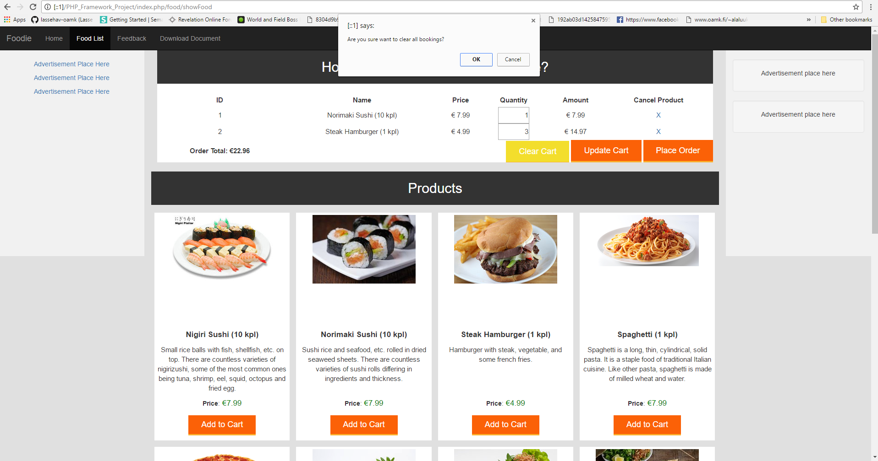

When you click on Clear Cart, the site will ask you if you want to delete all the items in the cart, so it is considered that there is a confirmation when you want to delete the items.

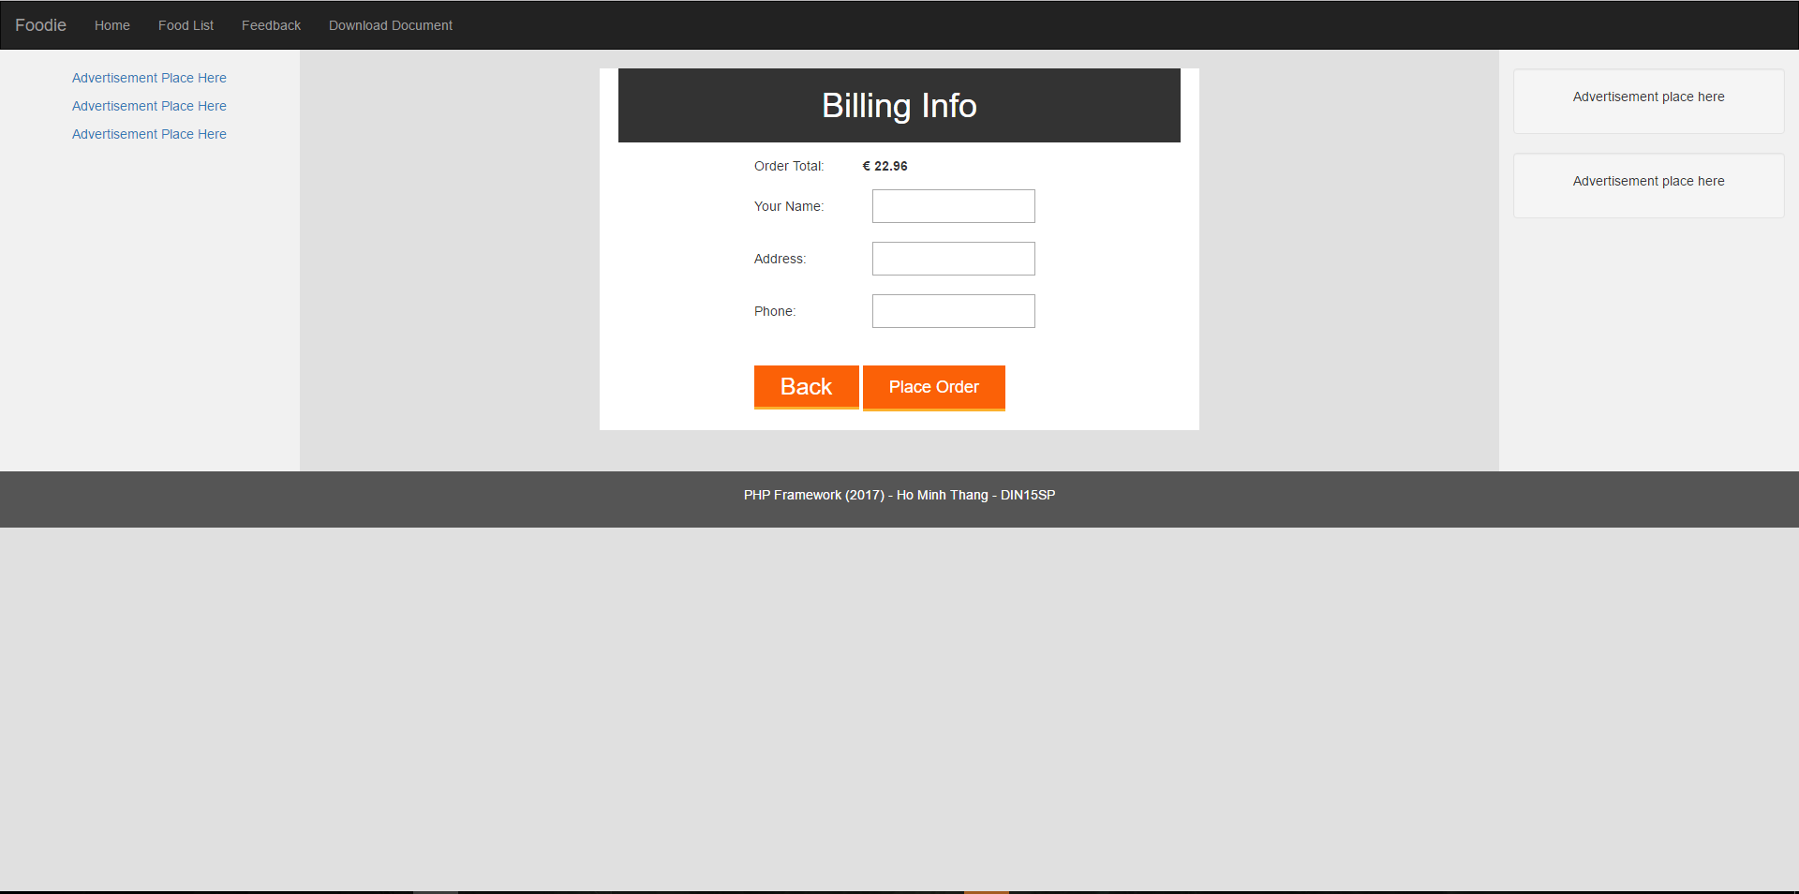

And tada ☺, I just clicked on Place order and the billing info just appeared there.

Fill in those blanks, and your food is delivered, just hold your cash, and I will come and deliver to your address soon!

(Will update the credit card system payment soon!)



And then a page Thank you will appear in animation reporting that I have received your order, and the page will automatically directs back to the food product page, and all the previous items in the cart will be deleted.

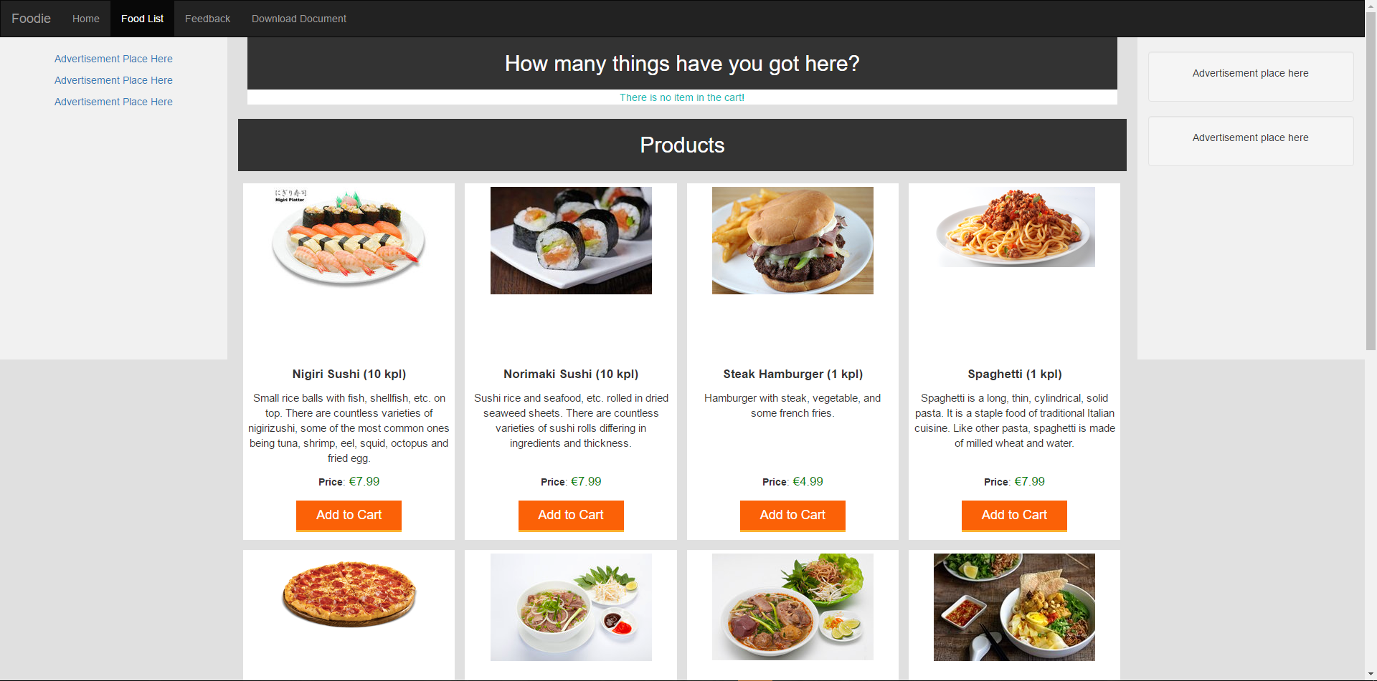

So after all of that, we return back to our product page.

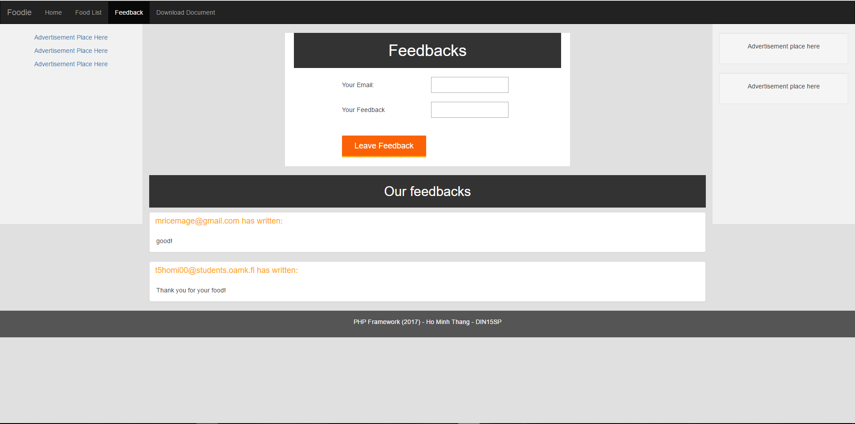

One small part here is also the feedback page, so that the anonymous is free to comment here, just fill in your email and feedback message, it will publicly show below!

Advertisement will appear in the future!

So I think that we have come to an end of our instruction. Thank you for watching this document.